Steps to run this Application:

Step 1:

Unzip both frontend and backend folder by right clicking on it ->and select Extract all option -> folder get unzipped.

Step 2:

Install :-

Visual Studio Code [For Frontend]

(Prerequisite : Download and Install Node JS)

Eclipse [For Backend]

(Prerequisite : Download and Install Java 17 JRE/JDK , Set Environment Variable)

After installing Eclipse install JBoss and Hibernate step are…

Go to Help in the top menu bar -> then click on Eclipse Marketplace ->type JBoss in search box ->

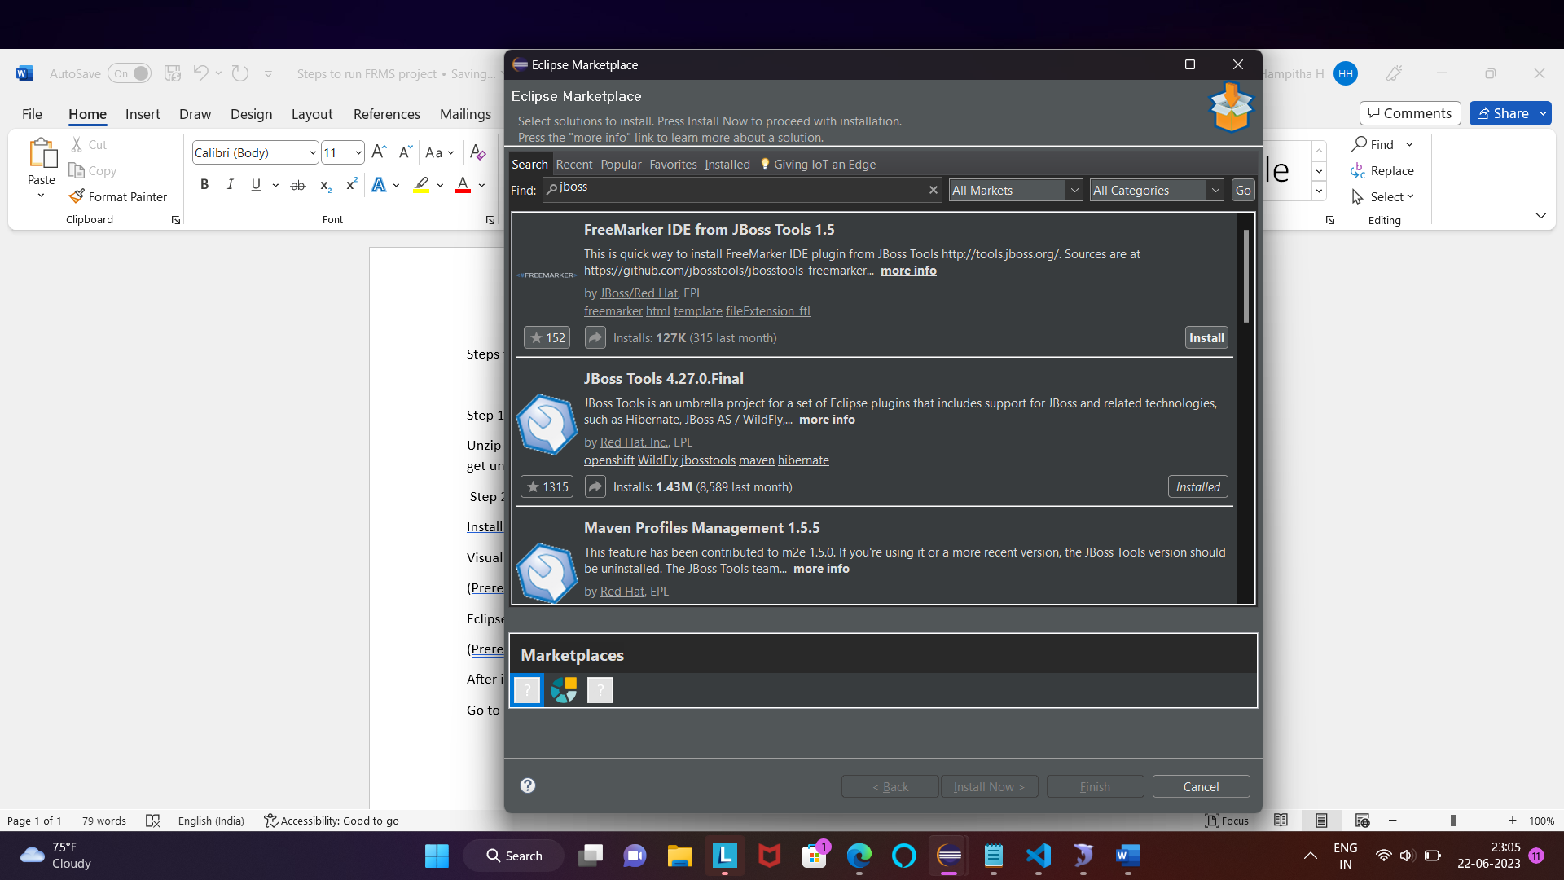

And install JBoss Tools 4.27.0.Final.

Then type Hibernate in search box ->

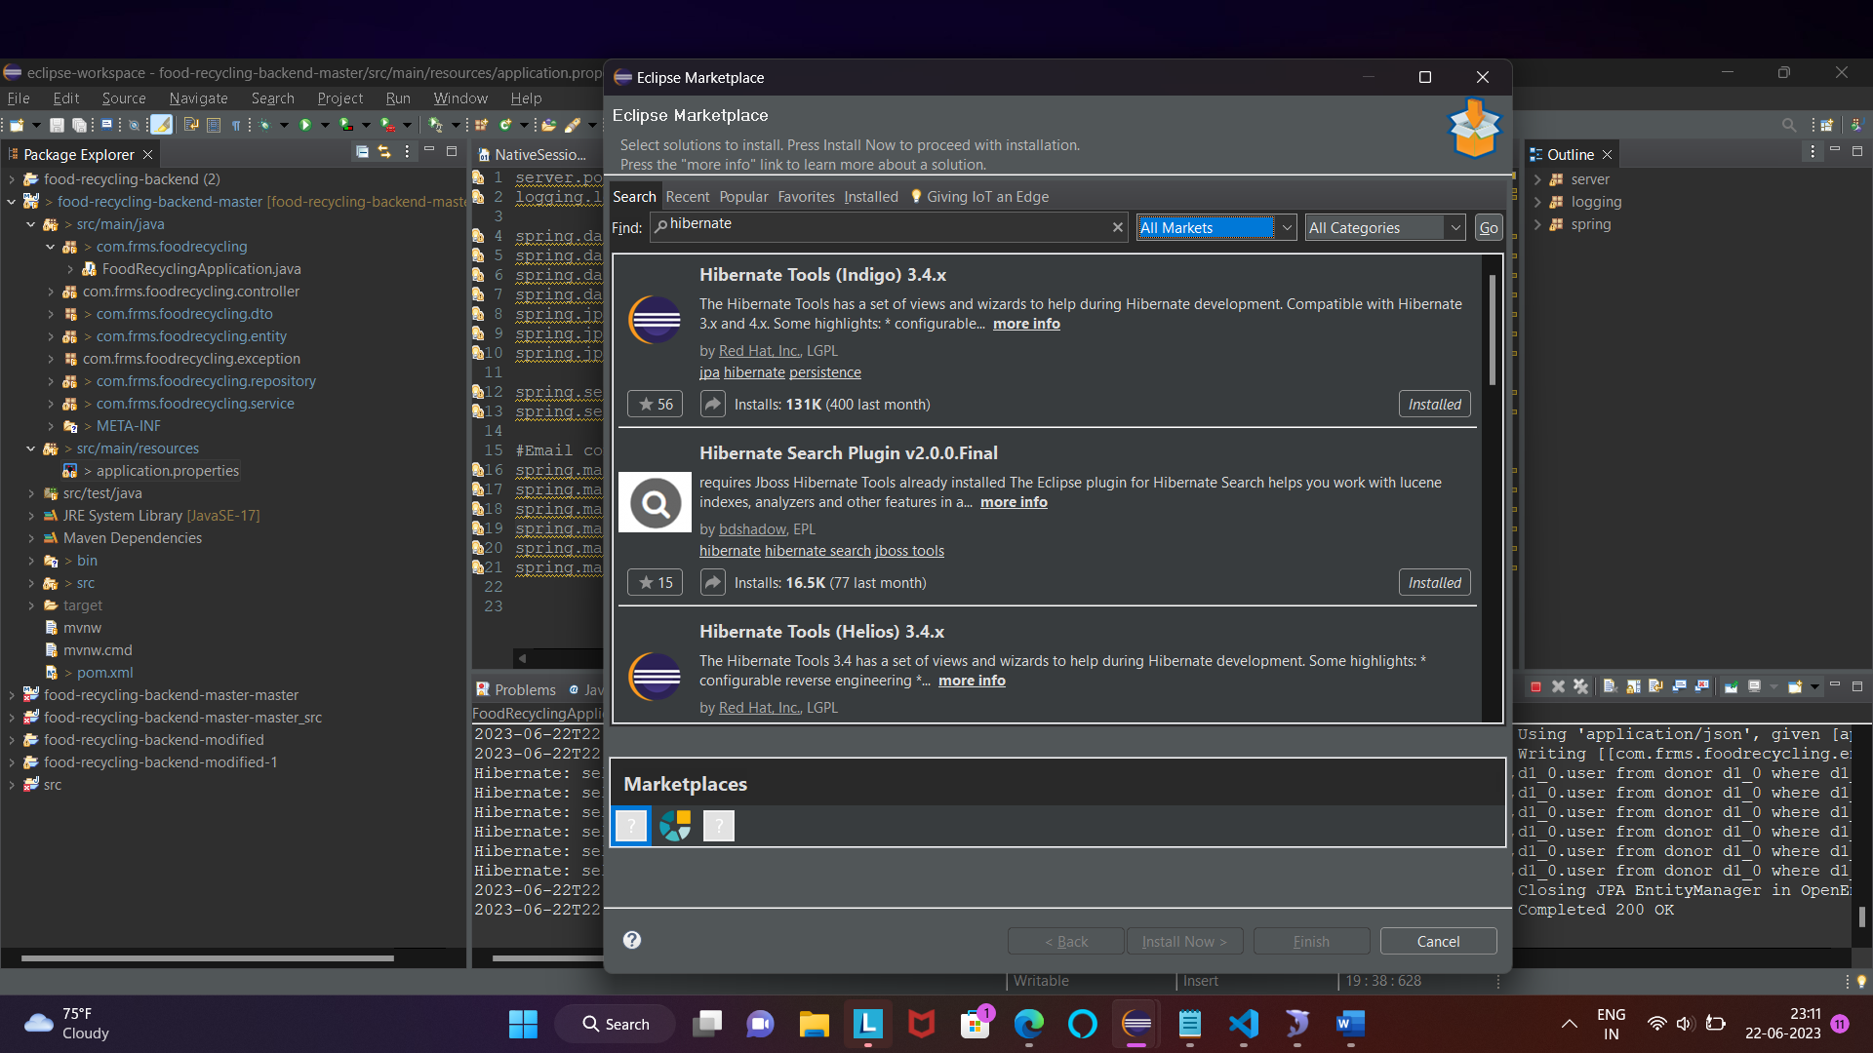

And install Hibernate Search Plugin v2.0.0.Final and all Hibernate Tools.

SQLyog [For DataBase]

(Prerequisite : Download and Install Mysql version 5.1.36 or you can all have latest version too )

Step 3:

Go to VSCode and click on file -> select open Folder -> select unzip frontend folder not files that are present inside ,make sure to select complete folder means (food-recycling-frontend-master-master).

Then click on Terminal in the top -> select New terminal -> type command :-

1) npm install (to install everything and to run npm related commands)

2)npm start(to start our application frontend part )

Step 4:

Go to Eclipse and click on file -> select Open Projects from File System -> select Directory -> select unzip Backend folder means(Both food-recyclind backend(2) as well as food-recycling-backend-master

Go to Eclipse and click on file -> select Open Projects from File System -> select Directory -> select unzip Backend folder means(Both food-recyclind backend(2) as well as food-recycling-backend-master)

Then go to application properties and remove cj form this

spring.datasource.driver-class-name=com.mysql.cj.jdbc.Driver

to this

spring.datasource.driver-class-name=com.mysql.jdbc.Driver

then make sure the port number is 3306 not 3307

spring.datasource.url=jdbc:mysql://localhost:3306/food-recycling

Then go to pom.xml -> Add this maven dependency from searching it from google as Mysql Connector and version must be **same** as mysql u install in this system

<!-- https://mvnrepository.com/artifact/mysql/mysql-connector-java -->

<dependency>

<groupId>mysql</groupId>

<artifactId>mysql-connector-java</artifactId>

<version>5.1.36</version>

</dependency>